**Exercises**

**Exercise 1: Create a Simple View**

Goal: Create a view to show basic employee details.

Task:

Create a view named vw_EmployeeBasicInfo that displays EmployeeID, FirstName,

LastName, and DepartmentName by joining Employees and Departments

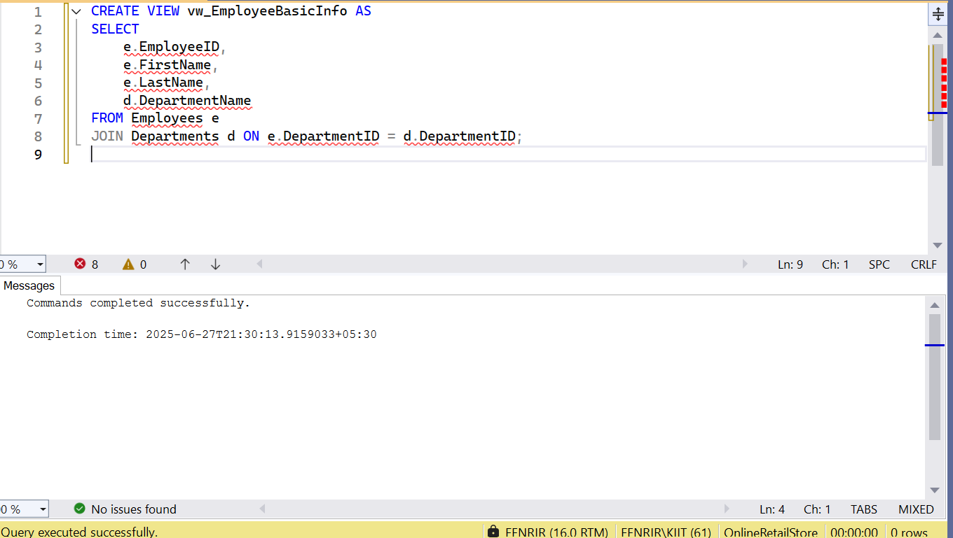

**Exercise 2: Add Computed Column - Full Name**

Goal: Use a computed column in a view.

Task:

Modify or create a view named vw_EmployeeFullName that includes a computed column

FullName (concatenation of FirstName and LastName).

Example Computed Column:

FirstName + ' ' + LastName AS FullNam

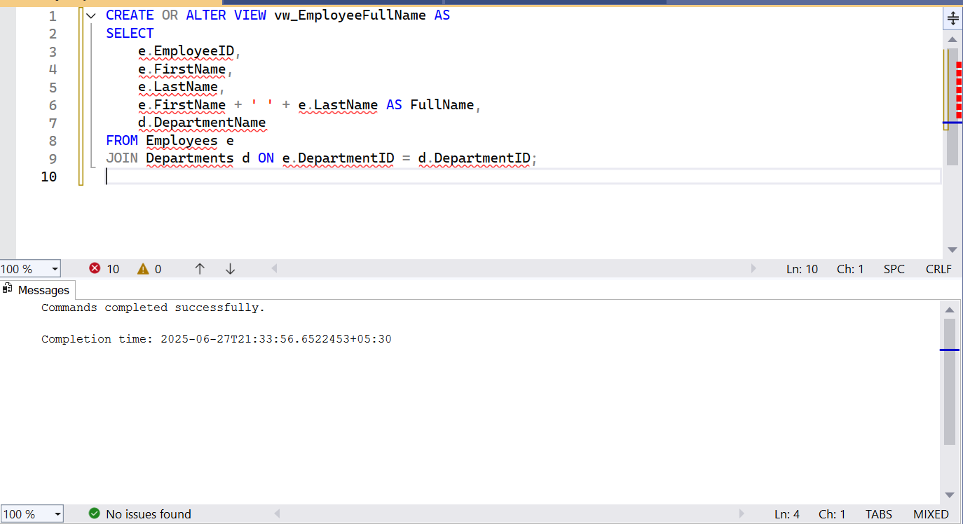

**Exercise 3: Add Computed Column - Annual Salary**

Goal: Add a financial computed column.

Task:

Create a view named vw_EmployeeAnnualSalary that includes a computed column

AnnualSalary (Salary * 12)

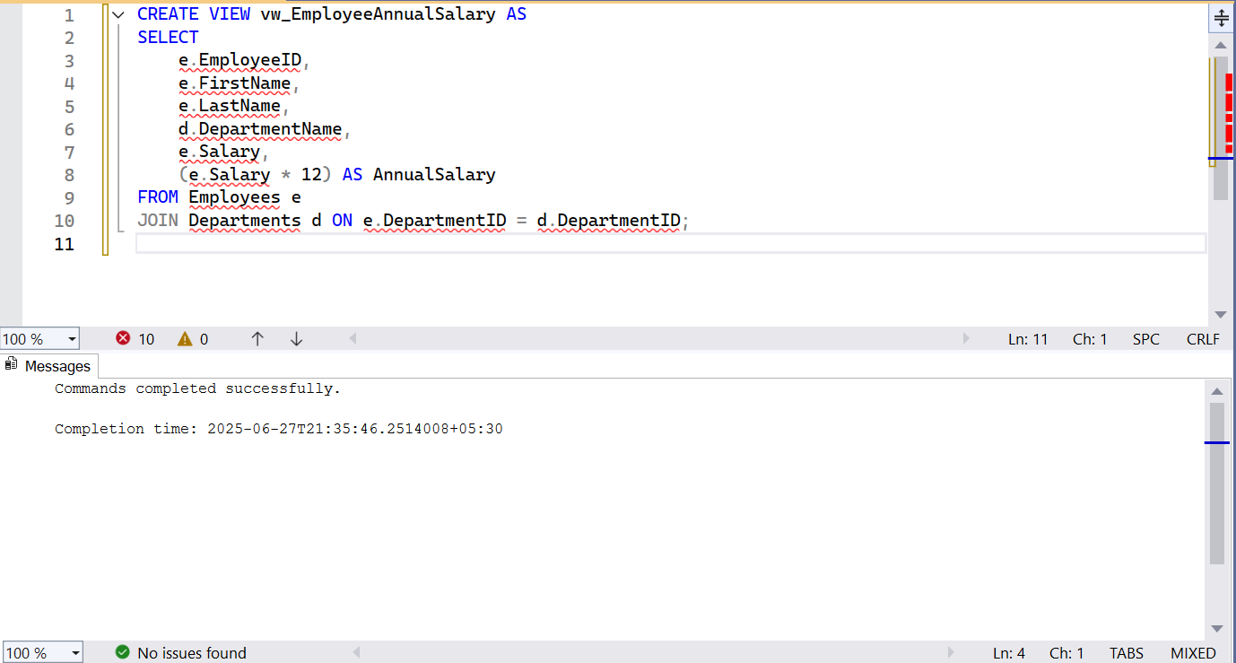

**Exercise 4: Add Multiple Computed Columns**

Goal: Combine multiple computed columns in a single view.

Task:

Create a view named vw_EmployeeReport that includes:

- EmployeeID

- FullName

- DepartmentName

- AnnualSalary

- Bonus (10% of AnnualSalary)

Example Bonus Calculation:

(Salary * 12) * 0.10 AS Bonus

